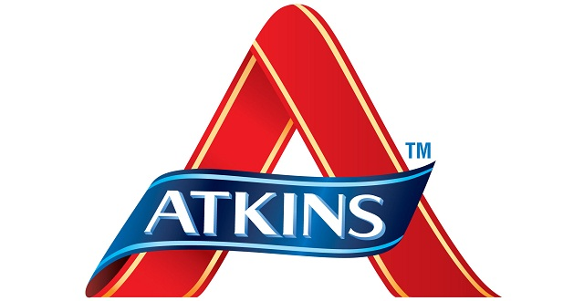**What is Atkins Diet?**

Today’s generation needs things to happen according to them. As a teenager, I like to control things I can. And losing weight tops the list. Every individual, whether young or old, like to stay in size. Not only physically but a mental satisfaction is connected to it. After all, who will not want to look younger than his/her age?

People run behind various diets and if they can’t select one, they change their schedules randomly. Sorry to say, all your efforts go waste this way.

What to choose then?

All you need is a diet plan which can help you shed some weight and change your lifestyle effectively. Atkins diet menu is here to your rescue. But what is Atkins diet? What is Atkins diet meal plan to follow? And what is Atkins diet beneficial for? Let’s find out what is Atkins diet and how does it work.

**What is Atkins diet?**

Atkins diet plan is based on low-carbohydrate diet. No strict restrictions are made on the amount of fats and proteins you intake. The Atkins foods are available with low carbohydrate amount. The inclusion of low-carbs in the diet is said to shed extra weight from the body and makes us fit. But what is Atkins diet routine? And what is Atkins diet food to eat and avoid?

An increased amount of protein in the diet reduces appetite and Atkins diet menu supports food with high proteins. Now, let’s see what is Atkins diet plan and how to follow it.

**Atkins diet and weight loss**

Atkins diet chart contains four segments as follows to answer: What is Atkins diet?

* First segment is called **Induction**. Atkins diet menu should contain less than 20 grams of carbs for first 2 weeks like green vegetables. Eat high-protein and high-fat diet.
* Second segment is called **Balancing**. This step includes increasing carbs in diet slowly. Add small amounts of fruits and green vegetables.
* Third segment is called **Fine-tuning**. This Atkins diet menu step is followed when you are about to reach your goal weight and slowly returning to your normal diet. It includes adding more carbs according to your body requirements. Stop to a level where weight stops losing further.
* Fourth segment is called **Maintenance**. This step represents the finish line. You can follow up your early routine (before taking the diet). Just remember to limit your diet to the amount of carbs your body can tolerate without gaining weight.

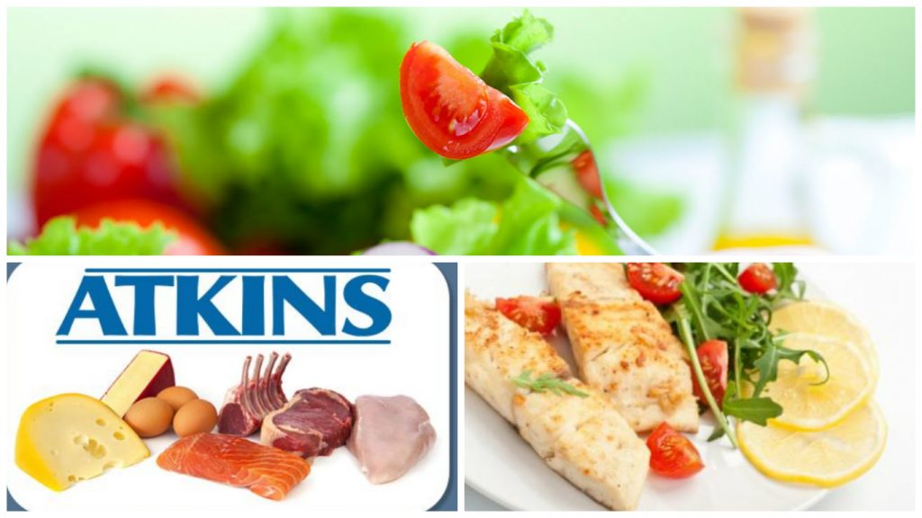

If you keep on increasing fats and carbs in your diet, you may gain weight. Obviously, Atkins diet and weight loss are related but certainly, it is not a magical scheme! It requires patience and dedication to achieve the goal. What is Atkins diet meal plan to follow? Have a look!

**Foods to eat and avoid**

There is an Atkins diet chart which contains Atkins recipes for you to follow. Look at the following foods to eat and avoid while on an Atkins diet plan.

**Atkins foods to eat**

* Dairy products: Cheese, butter, cream, yoghurt.
* Low-carb vegetables: Broccoli, spinach, asparagus.
* Eggs: Omega-3 or pastured eggs.
* Seafood: Sardines, salmon, trout etc.
* Meats: Beef, pork, bacon, chicken, lamb etc.
* Seeds and nuts: Almonds, walnuts etc.
* Oils: Coconut oil, avocado oil, extra virgin olive oil.

The above-mentioned Atkins foods are high in fats and include low-carbs as suggested.

**Atkins foods to avoid**

* High-carb vegetables: Turnip, carrot (for induction segment only).
* Trans fat: Processed food with ‘hydrogenated’ label.
* High starch food: Potato, sweet potato.
* Sugary eateries: Cake, soft drinks, candy, ice cream etc.
* Grains: wheat, rice, barley, rye.
* Legumes: Beans, lentils etc.

The above-mentioned Atkins foods are high in carbs. They must be avoided.

**Some exceptions**

* Beverages like coffee and green tea are considered healthy. While alcohol is small amounts is fine. Choose beverages with no added sugars.
* Dark chocolate in small quantity is acceptable.

**Concluding what is Atkins diet**

Now you know what is Atkins diet. Consult a dietician before starting with the Atkins recipes. Follow an Atkins diet and weight loss will follow you. Strictly follow the Atkins diet chart and foods to eat and avoid. Make sure you don’t have any health issues that might get serious. Happy dieting!